**Deploying javascript code**

**Deployment Steps**

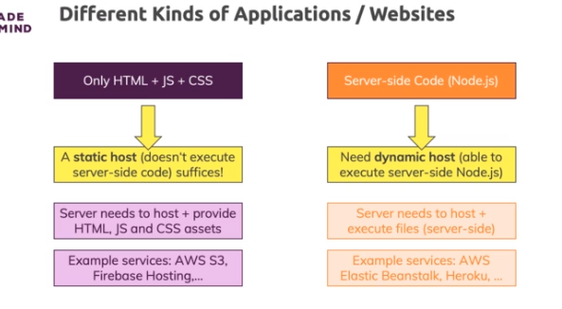

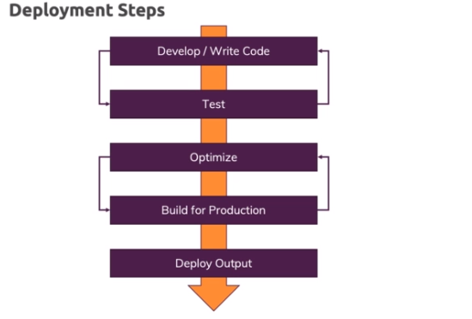

**Different Types of Websites**

You can build different kinds of websites/ web apps.

Specifically, there are three major types you can differentiate:

* Static Websites (just HTML + CSS + JS)
* Single-Page-Applications (SPAs, HTML + CSS + JS with only one HTML page being served, client-side JS is used to re-render the page dynamically)
* Dynamic/ Server-side rendered Web Applications: Websites where the HTML pages are created dynamically on the server (e.g. via templating engines like EJS).

You find a more detailed comparison here: <https://academind.com/learn/web-dev/dynamic-vs-static-vs-spa/>

When deploying such websites, it's important to understand that sites with NO server-side code (i.e. Static Websites and SPAs), required only a static host (e.g. AWS S3, Firebase Hosting).

Pages where HTML is generated dynamically on the server require a host that is capable of executing the server-side code (i.e. a server that supports NodeJS, PHP or whatever language is being used).

**Injecting Script Imports Into HTML Automatically**

In the previous lecture, we manually adjusted the HTML files to import the generated JavaScript files.

For most projects, this is fine - you're probably not going to push out a new version of your scripts every few minutes.

But you could also automate this process if you wanted to - with the help of a special plugin for Webpack: [The HtmlWebpackPlugin](https://webpack.js.org/plugins/html-webpack-plugin/).

You can find a detailed documentation on how to use it on this page: <https://github.com/jantimon/html-webpack-plugin>